**Abstract:**

Technological advancement has found ways to improve human mechanical locomotion by utilizing exoskeletons. Engineers used different type of exoskeletons to accomplish these tasks. The purpose of this study is to show an overview structure of an arm exoskeleton that would operate the movement of the elbow. From the various trials and applying two methods of control. Admittance control and virtual wall provided a desirable force and movement control of the wearable exoskeleton arm.

**Background Introduction:**

Exoskeleton have developed an interface between humans and robotics. This connection can bring many benefits and some down sides to humans’ daily life. Some benefits are the ability help individuals with disability or people that need to load assistance. Some down sides are that if perfectly healthy people start using such exoskeleton, it would cause them to lose muscle which is not ideal.

The design of the exoskeleton must take into consideration the biomechanics, which determine how the exoskeleton must behave in term of motion and force. These biomechanics in this project must be represented and simulated with the mechatronics components for example actuators and sensors. The exoskeleton arm movement should be limited the elbow has a certain range of motion. To implement a control system, an admittance control and virtual wall. These types of controls are usually implemented for industrial robots, which are mainly used for manufacturing. But the exoskeleton needs to be control in such way to follow the movement of the user while the user applies some force.

**Biomechanics:**

The human bodies operate at high torque and low speed. Many exoskeletons are now being design as a way to reduce metabolic cost and to increase the mechanical power output. An important notion had to be taken into consideration is the degree of freedom of the elbow. The elbow provides a range of motion of degree of freedom of about 140° from a neutral axis of the arm being extended as shown in the Figure 1.

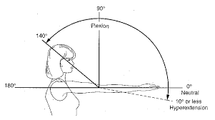

***Figure 1:*** Range of motion of the elbow.

**Hardware:**

For this arm exoskeleton, a servo motor was used as a mean of torque production and movement. A load cell sensor was used in order to obtain the force measurements. An Inertial Measurement Unit (IMU) sensor are devices that measures velocity, orientation, and gravitational forces, for this case only position orientation was measured. In order to implement the load cell to the exoskeleton, the sensor had to be calibrated.

**Design:**

The wearable arm exoskeleton is design is quite simple, it uses arm bands to provide attachment to the arm. The servo motor is located at the elbow, where the servo motor would provide torque and move the forearm. This motor would be assisted by a force sensor so the data taken from the force sensor would be feed into the micro-controller and then this would control the servo motor. The load cell is located at the forearm to sense any force that need assistance. As for the IMU sensor, this would be located on the forearm as well, but it was not incorporated in the testing. The micro-controller that was used was the Arduino Uno. These components are shown in the Figure 2 below excluding the IMU sensor.

***Figure 2:*** Setup of the exoskeleton with all used components.

This particular design had a limit on the range of motion in the elbow that is about 90°, this is less then the actual range of motion of the elbow as previously mentioned. This is due to the limited motion of the servo motor.

**Control System:**

Two methods of control were performed, admittance control and virtual wall. This set an algorithm that is implemented Arduino Uno that define the behavior of the systems. Admittance control would measure the interaction force of the user and the exoskeleton and then it controls the exoskeleton the movement accordingly by the use of the servo motor as shown in Figure.

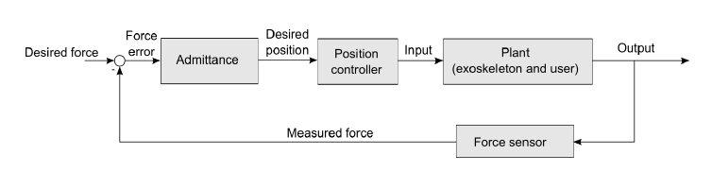

***Figure 3:*** Feedback close loop of the admittance control.

The figure above shows the mathematical control system that defines the relationship between force and position, this system is similar to that of a spring or damper. As for the virtual wall control, follows a similar structure as the admittance control but this sets a certain range of motion. This limited range of motion can be the biomechanical limits of the elbow and the limit that the servo motor has. Therefore, virtual wall would be the most ideal control for an exoskeleton arm.

**Test:**

First the calibration of the force sensor had to be done by measuring known objects units of Grams, then using the force sensor to record some voltage. The calibration was done by using the code from SparkFun_HX711. This let the user record a known weight and a calibration factor can be set, then this known weight is used as a reference to know what the amount of force is the user is applying. To the servo motor a previous task was performed to confirm that this motor works properly.

For admittance control, the force sensor needs to read the user input. This input has to provide some feedback position to the servo motor that would move the exoskeleton accordingly to the user movement. For this a function called map() was utilized, this function would take some values of from the input of the force sensor (low value of force, high value of force) and map these to some degree of rotation to move the servo motor (low value of degree, high value of degree) so the function would look like this: map(low_foce,high_foce,low_deg,high_deg)

Know this value would be equal to a given variable then this can be set by knowing the current position of the servo motor using the function myservo.read(), now the currently position can be change with the values given from the mapping function.

For virtual wall, the procedure was the same as the admittance control, but the only difference is that there must be a limit in the movement that the servo motor can move, and this can be done with an if statement.

**Conclusion:**

Overall, this project taught me many aspects of a mechatronics system and the many things that must be taken into consideration to achieve a properly working system. I want to keep working with the exoskeleton arm and try to implement the IMU sensor to the already working admittance control and virtual. Also implement many other types of PID controls to the see the many type of behavior and applications I can achieve. I have a big interest in mechatronics specially in implementation of machine learning to robots and I hope I can stay in this field.

**References:**

[1] Test Recording link: <https://www.youtube.com/watch?v=cAAaqB6cg30&ab_channel=WalmyMarine>

[2] Presentation link: <https://www.youtube.com/watch?v=peL6eMRJv3I&ab_channel=WalmyMarine>

[3] Github SparkFun_HX711 link: <https://github.com/sparkfun/HX711-Load-Cell-Amplifier/blob/master/firmware/SparkFun_HX711_Calibration/SparkFun_HX711_Calibration.ino>

**Appendix:**

Admittance Control Code:

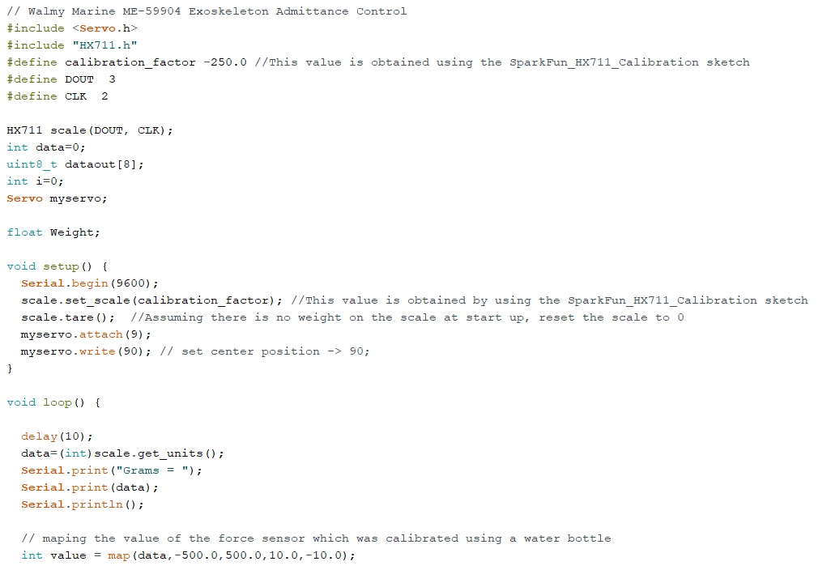

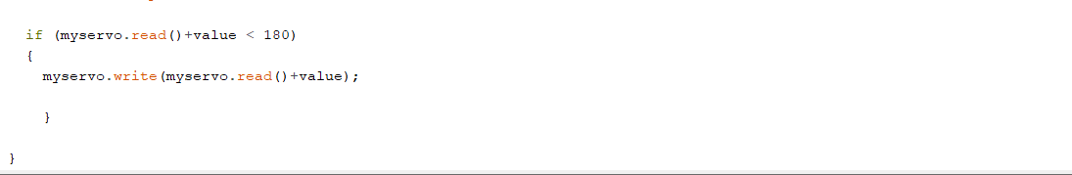

Virtual Wall Control Code:

